check 3

# check 3

## Question 1

Which of the following is not a correct statement for primary aliphatic amines?

1. The intermolecular association in primary amines is less than the intermolecular association in secondary amines.
2. Primary amines on treating with nitrous acid solution form corresponding alcohols except methyl amine.
3. Primary amines are less basic than the secondary amines.
4. Primary amines can be prepared by the gabriel phthalimide synthesis.

## Question 2

In the reaction of hypobromite with amide, the carbonyl carbon is lost as

1. \(\mathrm{CO}_3{ }^{2-}\)
2. \(\mathrm{HCO}_3{ }^{-}\)
3. \(\mathrm{CO}_2\)
4. \(\mathrm{CO}\)

## Question 3

Which one of the products of the following reactions does not react with Hinsberg reagent to form sulphonamide? [25 Jul 2021]

1. 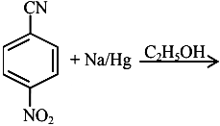
2. 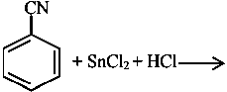
3. 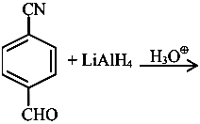
4. 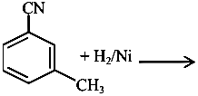

## Question 4

An organic compound "A" on treatment with benzene sulphonyl chloride gives compound \(B . B\) is soluble in dil. \(\mathrm{NaOH}\) solution.

Compound \(A\) is______________.

1. \(\mathrm{C}_6 \mathrm{H}_5-\mathrm{N}-\left(\mathrm{CH}_3\right)_2\)
2. \(\mathrm{C}_6 \mathrm{H}_5-\mathrm{NHCH}_2 \mathrm{CH}_3\)
3. \(\mathrm{C}_6 \mathrm{H}_5-\mathrm{CH}_2 \mathrm{NHCH}_3\)
4. \(\mathrm{C}_6 \mathrm{H}_5-\mathrm{CH}-\mathrm{NH}_2\)

## Question 5

The number of nitrogen atoms in a semicarbazone molecule of acetone is_____________.

## Question 6

The total number of reagents from those given below, that can convert nitrobenzene into aniline is _______________ (Integer answer)

|  |  |
| --- | --- |
| \(I . \mathrm{Sn}-\mathrm{HCI}\) | \(\mathrm{II} \cdot \mathrm{Sn}-\mathrm{NH}_4 \mathrm{OH}\) |
| \(I I I \cdot \mathrm{Fe}-\mathrm{HCl}\) | \(I V \cdot \mathrm{Zn}-\mathrm{HCI}\) |
| \(V \cdot \mathrm{H}_2-\mathrm{Pd}\) | \(V I \cdot \mathrm{H}_2-\) Raney nickel |

## Question 7

Primary, secondary and tertiary amines can be separated using.

1. para-toluene sulphonyl chloride
2. chloroform and \(\mathrm{KOH}\)
3. benzene sulphonic acid
4. acetyl amide

## Question 8

Compound \(\mathrm{A}\) is converted to \(\mathrm{B}\) on reaction with \(\mathrm{CHCl}_3\) and \(\mathrm{KOH}\). The compound \(\mathrm{B}\) is toxic and can be decomposed by C. A, B and \(C\) respectively are :

1. primary amine, nitrile compound, conc. \(\mathrm{HCl}\)
2. secondary amine, isonitrile compound, conc. \(\mathrm{NaOH}\)
3. primary amine, isonitrile compound, conc. \(\mathrm{HCl}\)
4. secondary amine, nitrile compound, conc. \(\mathrm{NaOH}\)

## Question 9

Consider the following sequence of reaction :

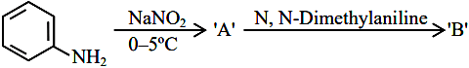

The product ' \(\mathrm{B}\) ' is :

1. 
2. 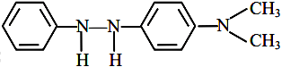
3. 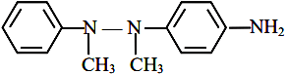
4. 

## Question 10

Number of isomeric aromatic amines with molecular formula \(\mathrm{C}_8 \mathrm{H}_{11} \mathrm{~N}\), which can be synthesized by Gabriel Phthalimide synthesis is ___________.  [6-Apr-2023]

## Question 11

Hydrolysis of which compound will give carbolic acid?

1. Cumene
2. Benzenediazonium chloride
3. Benzal chloride
4. Ethylene glycol ketal

## Question 12

During halogen test, sodium fusion extract is boiled with concentrated \(\mathrm{HNO}_3\) to

1. remove unreacted sodium
2. decompose cyanide or sulphide of sodium
3. extract halogen from organic compound
4. maintain the \(\mathrm{pH}\) of extract.

## Question 13

The most appropriate reagent for conversion of \(\mathrm{C}_2 \mathrm{H}_5 \mathrm{CN}\) into \(\mathrm{CH}_3 \mathrm{CH}_2 \mathrm{CH}_2 \mathrm{NH}_2\) is:

1. \(\mathrm{NaBH}_4\)
2. \(\mathrm{CaH}_2\)
3. LiAl H\(_4\)
4. \(\mathrm{Na}(\mathrm{CN}) \mathrm{BH}_3\)

## Question 14

The decreasing order of basicity of the following amines is:

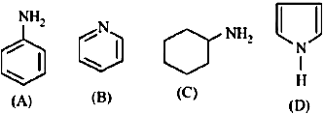

1. \((A)>(C)>(D)>(B)\)
2. \((C)>(A)>(B)>(D)\)
3. \((B)>(C)>(D)>(A)\)
4. \((C)>(B)>(A)>(D)\)

## Question 15

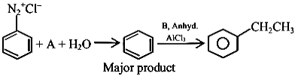

In the chemical reactions given above \(A\) and \(B\) respectively are:

1. \(\mathrm{H}_3 \mathrm{PO}_2\) and \(\mathrm{CH}_3 \mathrm{CH}_2 \mathrm{Cl}\)
2. \(\mathrm{CH}_3 \mathrm{CH}_2 \mathrm{OH}\) and \(\mathrm{H}_3 \mathrm{PO}_2\)
3. \(\mathrm{H}_3 \mathrm{O}_2\) and \(\mathrm{CH}_3 \mathrm{CH}_2 \mathrm{OH}\)
4. \(\mathrm{CH}_3 \mathrm{CH}_2 \mathrm{Cl}\) and \(\mathrm{H}_3 \mathrm{PO}_2\)

## Question 16

The number of primary amines of formula \(\mathrm{C}_4 \mathrm{H}_{11} \mathrm{~N}\) is ?

## Question 17

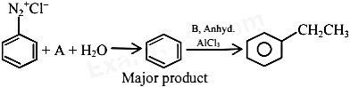

In the chemical reactions given above \(A\) and \(B\) respectively are:

1. \(\mathrm{H}_3 \mathrm{PO}_2\) and \(\mathrm{CH}_3 \mathrm{CH}_2 \mathrm{Cl}\)
2. \(\mathrm{CH}_3 \mathrm{CH}_2 \mathrm{OH}\) and \(\mathrm{H}_3 \mathrm{PO}_2\)
3. \(\mathrm{H}_3 \mathrm{O}_2\) and \(\mathrm{CH}_3 \mathrm{CH}_2 \mathrm{OH}\)
4. \(\mathrm{CH}_3 \mathrm{CH}_2 \mathrm{Cl}\) and \(\mathrm{H}_3 \mathrm{PO}_2\)

## Question 18

The product A formed in the following reaction is:

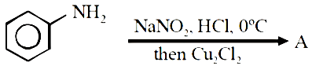

1. 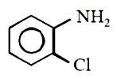
2. 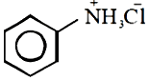
3. 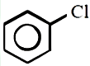
4. 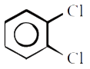

## Question 19

The products A and B formed in the following reaction scheme are respectively

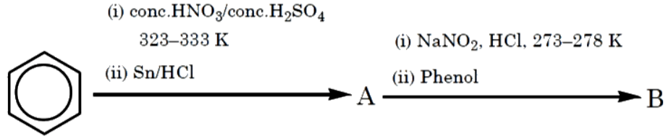

1. 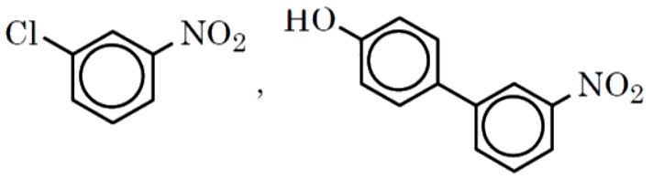
2. 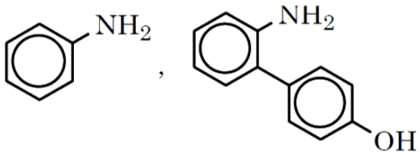
3. 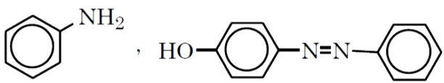
4. 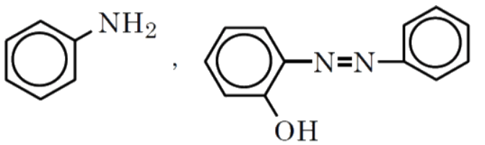

## Question 20

Which one of the products of the following reactions does not react with Hinsberg reagent to form sulphonamide? [25 Jul 2021]

1. 
2. 
3. 
4. 

## Question 21

An organic compound "A" on treatment with benzene sulphonyl chloride gives compound \(B . B\) is soluble in dil. \(\mathrm{NaOH}\) solution.

Compound \(A\) is______________.

1. \(\mathrm{C}_6 \mathrm{H}_5-\mathrm{N}-\left(\mathrm{CH}_3\right)_2\)
2. \(\mathrm{C}_6 \mathrm{H}_5-\mathrm{NHCH}_2 \mathrm{CH}_3\)
3. \(\mathrm{C}_6 \mathrm{H}_5-\mathrm{CH}_2 \mathrm{NHCH}_3\)
4. \(\mathrm{C}_6 \mathrm{H}_5-\mathrm{CH}-\mathrm{NH}_2\)

## Question 22

The number of nitrogen atoms in a semicarbazone molecule of acetone is_____________.

## Question 23

The total number of reagents from those given below, that can convert nitrobenzene into aniline is _______________ (Integer answer)

|  |  |
| --- | --- |
| \(I . \mathrm{Sn}-\mathrm{HCI}\) | \(\mathrm{II} \cdot \mathrm{Sn}-\mathrm{NH}_4 \mathrm{OH}\) |
| \(I I I \cdot \mathrm{Fe}-\mathrm{HCl}\) | \(I V \cdot \mathrm{Zn}-\mathrm{HCI}\) |
| \(V \cdot \mathrm{H}_2-\mathrm{Pd}\) | \(V I \cdot \mathrm{H}_2-\) Raney nickel |

## Question 24

A primary aliphatic amine on reaction with nitrous acid in cold ( \(273 \mathrm{~K})\) and there after raising temperature of reaction mixture to room temperature (298 K), gives.

1. nitrile
2. alcohol
3. diazonium salt
4. secondary amine

## Question 25

Primary, secondary and tertiary amines can be separated using.

1. para-toluene sulphonyl chloride
2. chloroform and \(\mathrm{KOH}\)
3. benzene sulphonic acid
4. acetyl amide

## Question 26

Given below are two statements :

Statement I : In Hofmann degradation reaction, the migration of only an alkyl group takes place from carbonyl carbon of the amide to the nitrogen atom.

Statement II : The group is migrated in Hofmann degradation reaction to electron deficient atom.

In the light of the above statements, choose the most appropriate answer from the options given below:

1. Both Statement I and Statement II are correct.
2. Both Statement I and Statement II are incorrect.
3. Statement I is correct but Statement II is incorrect.
4. Statement I is incorrect but Statement II is correct.

## Question 27

During halogen test, sodium fusion extract is boiled with concentrated \(\mathrm{HNO}_3\) to

1. remove unreacted sodium
2. decompose cyanide or sulphide of sodium
3. extract halogen from organic compound
4. maintain the \(\mathrm{pH}\) of extract.

## Question 28

A compound with molecular mass 180 is acylated with \(\mathrm{CH}_3 \mathrm{COCl}\) to get a compound with molecular mass 390 . The number of amino groups present per molecule of the former compound is:

## Question 29

The most appropriate reagent for conversion of \(\mathrm{C}_2 \mathrm{H}_5 \mathrm{CN}\) into \(\mathrm{CH}_3 \mathrm{CH}_2 \mathrm{CH}_2 \mathrm{NH}_2\) is:

1. \(\mathrm{NaBH}_4\)
2. \(\mathrm{CaH}_2\)
3. LiAl H\(_4\)
4. \(\mathrm{Na}(\mathrm{CN}) \mathrm{BH}_3\)

## Question 30

The decreasing order of basicity of the following amines is:



1. \((A)>(C)>(D)>(B)\)
2. \((C)>(A)>(B)>(D)\)
3. \((B)>(C)>(D)>(A)\)
4. \((C)>(B)>(A)>(D)\)

## Question 31

\(C_7 H_9 N \mid\) has how many isomeric forms that contain a benzene ring?

## Question 32

The total number of electrons around the nitrogen atom in amines are,

## Question 33

The number of primary amines of formula \(\mathrm{C}_4 \mathrm{H}_{11} \mathrm{~N}\) is ?

## Question 34

The products A and B formed in the following reaction scheme are respectively



1. 
2. 
3. 
4. 

## Question 35

Number of compounds which give reaction with Hinsberg's reagent is _______.

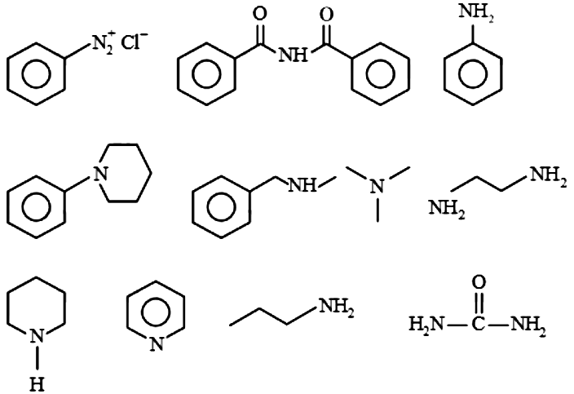

## Question 36

In the reaction of hypobromite with amide, the carbonyl carbon is lost as

1. \(\mathrm{CO}_3{ }^{2-}\)
2. \(\mathrm{HCO}_3{ }^{-}\)
3. \(\mathrm{CO}_2\)
4. \(\mathrm{CO}\)

## Question 37

The number of nitrogen atoms in a semicarbazone molecule of acetone is_____________.

## Question 38

A primary aliphatic amine on reaction with nitrous acid in cold ( \(273 \mathrm{~K})\) and there after raising temperature of reaction mixture to room temperature (298 K), gives.

1. nitrile
2. alcohol
3. diazonium salt
4. secondary amine

## Question 39

Primary, secondary and tertiary amines can be separated using.

1. para-toluene sulphonyl chloride
2. chloroform and \(\mathrm{KOH}\)
3. benzene sulphonic acid
4. acetyl amide

## Question 40

The major product formed in the following reaction is.

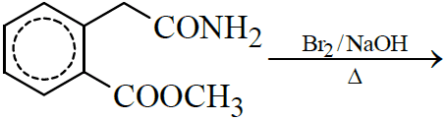

1. 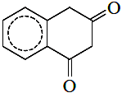
2. 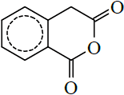
3. 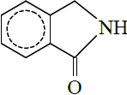
4. 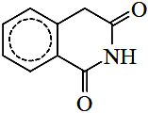

## Question 41

Choose the correct colour of the product for the following reaction.

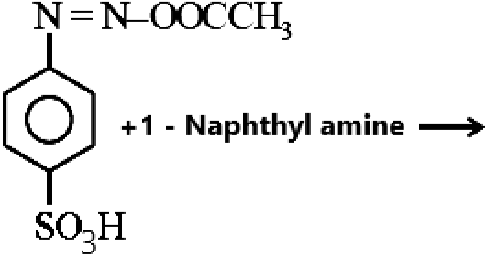

1. Yellow
2. White
3. Red
4. Blue

## Question 42

The correct order in aqueous medium of basic strength in case of methyl substituted amines is :

1. \(\mathrm{Me}_2 \mathrm{NH}>\mathrm{MeNH}_2>\mathrm{Me}_3 \mathrm{~N}>\mathrm{NH}_3\)
2. \(\mathrm{Me}_2 \mathrm{NH}>\mathrm{Me}_3 \mathrm{~N}>\mathrm{MeNH}_2>\mathrm{NH}_3\)
3. \(\mathrm{NH}_3>\mathrm{Me}_3 \mathrm{~N}>\mathrm{MeNH}_2>\mathrm{Me}_2 \mathrm{NH}\)
4. \(\mathrm{Me}_3 \mathrm{~N}>\mathrm{Me}_2 \mathrm{NH}>\mathrm{MeNH}_2>\mathrm{NH}_3\)

## Question 43

Number of isomeric aromatic amines with molecular formula \(\mathrm{C}_8 \mathrm{H}_{11} \mathrm{~N}\), which can be synthesized by Gabriel Phthalimide synthesis is ___________.  [6-Apr-2023]

## Question 44

Hydrolysis of which compound will give carbolic acid?

1. Cumene
2. Benzenediazonium chloride
3. Benzal chloride
4. Ethylene glycol ketal

## Question 45

During halogen test, sodium fusion extract is boiled with concentrated \(\mathrm{HNO}_3\) to

1. remove unreacted sodium
2. decompose cyanide or sulphide of sodium
3. extract halogen from organic compound
4. maintain the \(\mathrm{pH}\) of extract.

## Question 46

A compound with molecular mass 180 is acylated with \(\mathrm{CH}_3 \mathrm{COCl}\) to get a compound with molecular mass 390 . The number of amino groups present per molecule of the former compound is:

## Question 47



In the chemical reactions given above \(A\) and \(B\) respectively are:

1. \(\mathrm{H}_3 \mathrm{PO}_2\) and \(\mathrm{CH}_3 \mathrm{CH}_2 \mathrm{Cl}\)
2. \(\mathrm{CH}_3 \mathrm{CH}_2 \mathrm{OH}\) and \(\mathrm{H}_3 \mathrm{PO}_2\)
3. \(\mathrm{H}_3 \mathrm{O}_2\) and \(\mathrm{CH}_3 \mathrm{CH}_2 \mathrm{OH}\)
4. \(\mathrm{CH}_3 \mathrm{CH}_2 \mathrm{Cl}\) and \(\mathrm{H}_3 \mathrm{PO}_2\)

## Question 48

The number of primary amines of formula \(\mathrm{C}_4 \mathrm{H}_{11} \mathrm{~N}\) is ?

## Question 49

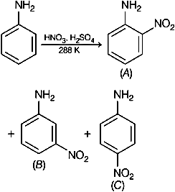

Consider the given reaction, percentage yield of,

1. \((C)>(A)>(B)\)
2. \((B)>(C)>(A)\)
3. \((A)>(C)>(B)\)
4. \((C)>(B)>(A)\)

## Question 50



In the chemical reactions given above \(A\) and \(B\) respectively are:

1. \(\mathrm{H}_3 \mathrm{PO}_2\) and \(\mathrm{CH}_3 \mathrm{CH}_2 \mathrm{Cl}\)
2. \(\mathrm{CH}_3 \mathrm{CH}_2 \mathrm{OH}\) and \(\mathrm{H}_3 \mathrm{PO}_2\)
3. \(\mathrm{H}_3 \mathrm{O}_2\) and \(\mathrm{CH}_3 \mathrm{CH}_2 \mathrm{OH}\)
4. \(\mathrm{CH}_3 \mathrm{CH}_2 \mathrm{Cl}\) and \(\mathrm{H}_3 \mathrm{PO}_2\)

## Question 51

The product A formed in the following reaction is:



1. 
2. 
3. 
4. 

## Question 52

Number of compounds which give reaction with Hinsberg's reagent is _______.



## Question 53

Given below are two statements :

Statement I: Aniline reacts with con. \(\mathrm{H}_2 \mathrm{SO}_4\) followed by heating at \(453-473 \mathrm{~K}\) gives p-aminobenzene sulphonic acid, which gives blood red colour in the 'Lassaigne's test'.  
Statement II: In Friedel - Craft's alkylation and acylation reactions, aniline forms salt with the \(\mathrm{AlCl}_3\) catalyst.  
Due to this, nitrogen of aniline aquires a positive charge and acts as deactivating group.  
In the light of the above statements, choose the correct answer from the options given below :

1. Statement I is false but statement II is true
2. Both statement I and statement II are false
3. Statement I is true but statement II is false
4. Both statement I and statement II are true

## Question 54

Which of the following is not a correct statement for primary aliphatic amines?

1. The intermolecular association in primary amines is less than the intermolecular association in secondary amines.
2. Primary amines on treating with nitrous acid solution form corresponding alcohols except methyl amine.
3. Primary amines are less basic than the secondary amines.
4. Primary amines can be prepared by the gabriel phthalimide synthesis.

## Question 55

In the reaction of hypobromite with amide, the carbonyl carbon is lost as

1. \(\mathrm{CO}_3{ }^{2-}\)
2. \(\mathrm{HCO}_3{ }^{-}\)
3. \(\mathrm{CO}_2\)
4. \(\mathrm{CO}\)

## Question 56

An organic compound "A" on treatment with benzene sulphonyl chloride gives compound \(B . B\) is soluble in dil. \(\mathrm{NaOH}\) solution.

Compound \(A\) is______________.

1. \(\mathrm{C}_6 \mathrm{H}_5-\mathrm{N}-\left(\mathrm{CH}_3\right)_2\)
2. \(\mathrm{C}_6 \mathrm{H}_5-\mathrm{NHCH}_2 \mathrm{CH}_3\)
3. \(\mathrm{C}_6 \mathrm{H}_5-\mathrm{CH}_2 \mathrm{NHCH}_3\)
4. \(\mathrm{C}_6 \mathrm{H}_5-\mathrm{CH}-\mathrm{NH}_2\)

## Question 57

Primary, secondary and tertiary amines can be separated using.

1. para-toluene sulphonyl chloride
2. chloroform and \(\mathrm{KOH}\)
3. benzene sulphonic acid
4. acetyl amide

## Question 58

Compound \(\mathrm{A}\) is converted to \(\mathrm{B}\) on reaction with \(\mathrm{CHCl}_3\) and \(\mathrm{KOH}\). The compound \(\mathrm{B}\) is toxic and can be decomposed by C. A, B and \(C\) respectively are :

1. primary amine, nitrile compound, conc. \(\mathrm{HCl}\)
2. secondary amine, isonitrile compound, conc. \(\mathrm{NaOH}\)
3. primary amine, isonitrile compound, conc. \(\mathrm{HCl}\)
4. secondary amine, nitrile compound, conc. \(\mathrm{NaOH}\)

## Question 59

The major product formed in the following reaction is.



1. 
2. 
3. 
4. 

## Question 60

Consider the following sequence of reaction :



The product ' \(\mathrm{B}\) ' is :

1. 
2. 
3. 
4. 

## Question 61

The correct order in aqueous medium of basic strength in case of methyl substituted amines is :

1. \(\mathrm{Me}_2 \mathrm{NH}>\mathrm{MeNH}_2>\mathrm{Me}_3 \mathrm{~N}>\mathrm{NH}_3\)
2. \(\mathrm{Me}_2 \mathrm{NH}>\mathrm{Me}_3 \mathrm{~N}>\mathrm{MeNH}_2>\mathrm{NH}_3\)
3. \(\mathrm{NH}_3>\mathrm{Me}_3 \mathrm{~N}>\mathrm{MeNH}_2>\mathrm{Me}_2 \mathrm{NH}\)
4. \(\mathrm{Me}_3 \mathrm{~N}>\mathrm{Me}_2 \mathrm{NH}>\mathrm{MeNH}_2>\mathrm{NH}_3\)

## Question 62

Number of isomeric aromatic amines with molecular formula \(\mathrm{C}_8 \mathrm{H}_{11} \mathrm{~N}\), which can be synthesized by Gabriel Phthalimide synthesis is ___________.  [6-Apr-2023]

## Question 63

Given below are two statements :

Statement I : In Hofmann degradation reaction, the migration of only an alkyl group takes place from carbonyl carbon of the amide to the nitrogen atom.

Statement II : The group is migrated in Hofmann degradation reaction to electron deficient atom.

In the light of the above statements, choose the most appropriate answer from the options given below:

1. Both Statement I and Statement II are correct.
2. Both Statement I and Statement II are incorrect.
3. Statement I is correct but Statement II is incorrect.
4. Statement I is incorrect but Statement II is correct.

## Question 64

A compound with molecular mass 180 is acylated with \(\mathrm{CH}_3 \mathrm{COCl}\) to get a compound with molecular mass 390 . The number of amino groups present per molecule of the former compound is:

## Question 65

The most appropriate reagent for conversion of \(\mathrm{C}_2 \mathrm{H}_5 \mathrm{CN}\) into \(\mathrm{CH}_3 \mathrm{CH}_2 \mathrm{CH}_2 \mathrm{NH}_2\) is:

1. \(\mathrm{NaBH}_4\)
2. \(\mathrm{CaH}_2\)
3. LiAl H\(_4\)
4. \(\mathrm{Na}(\mathrm{CN}) \mathrm{BH}_3\)

## Question 66

\(C_7 H_9 N \mid\) has how many isomeric forms that contain a benzene ring?

## Question 67

The number of primary amines of formula \(\mathrm{C}_4 \mathrm{H}_{11} \mathrm{~N}\) is ?

## Question 68



Consider the given reaction, percentage yield of,

1. \((C)>(A)>(B)\)
2. \((B)>(C)>(A)\)
3. \((A)>(C)>(B)\)
4. \((C)>(B)>(A)\)

## Question 69



In the chemical reactions given above \(A\) and \(B\) respectively are:

1. \(\mathrm{H}_3 \mathrm{PO}_2\) and \(\mathrm{CH}_3 \mathrm{CH}_2 \mathrm{Cl}\)
2. \(\mathrm{CH}_3 \mathrm{CH}_2 \mathrm{OH}\) and \(\mathrm{H}_3 \mathrm{PO}_2\)
3. \(\mathrm{H}_3 \mathrm{O}_2\) and \(\mathrm{CH}_3 \mathrm{CH}_2 \mathrm{OH}\)
4. \(\mathrm{CH}_3 \mathrm{CH}_2 \mathrm{Cl}\) and \(\mathrm{H}_3 \mathrm{PO}_2\)

## Question 70

The product A formed in the following reaction is:



1. 
2. 
3. 
4. 

## Question 71

The products A and B formed in the following reaction scheme are respectively



1. 
2. 
3. 
4. 

## Question 72

What is the correct name for a molecule that has two amino groups in opposing (para) locations around a benzene ring?

1. Benzenediamine
2. Benzene-1,4-diamine
3. p-Aminoaniline
4. 4-Aminobenzenamine

## Question 73

Which one of the products of the following reactions does not react with Hinsberg reagent to form sulphonamide? [25 Jul 2021]

1. 
2. 
3. 
4. 

## Question 74

An organic compound "A" on treatment with benzene sulphonyl chloride gives compound \(B . B\) is soluble in dil. \(\mathrm{NaOH}\) solution.

Compound \(A\) is______________.

1. \(\mathrm{C}_6 \mathrm{H}_5-\mathrm{N}-\left(\mathrm{CH}_3\right)_2\)
2. \(\mathrm{C}_6 \mathrm{H}_5-\mathrm{NHCH}_2 \mathrm{CH}_3\)
3. \(\mathrm{C}_6 \mathrm{H}_5-\mathrm{CH}_2 \mathrm{NHCH}_3\)
4. \(\mathrm{C}_6 \mathrm{H}_5-\mathrm{CH}-\mathrm{NH}_2\)

## Question 75

The number of nitrogen atoms in a semicarbazone molecule of acetone is_____________.

## Question 76

Match List I with List II.

|  |  |
| --- | --- |
| List-I | List-II |
| A. Benzenesulphonyl Chloride | I. Test for primary amines |
| B. Hoffmann bromamide reaction | II. Anti Saytzeff |
| C. Carbylamine reaction | III. Hinsberg reagent |
| D. Hoffmann orientation | IV. Known reaction of Isocyanates |

Choose the correct answer from the options given below:

1. A-IV, B-III, C-II, D-I
2. A-IV, B-II, C-I, D-II
3. A-III, B-IV, C-I, D-II
4. A-IV, B-III, C-I, D-II

## Question 77

Primary, secondary and tertiary amines can be separated using.

1. para-toluene sulphonyl chloride
2. chloroform and \(\mathrm{KOH}\)
3. benzene sulphonic acid
4. acetyl amide

## Question 78

Compound \(\mathrm{A}\) is converted to \(\mathrm{B}\) on reaction with \(\mathrm{CHCl}_3\) and \(\mathrm{KOH}\). The compound \(\mathrm{B}\) is toxic and can be decomposed by C. A, B and \(C\) respectively are :

1. primary amine, nitrile compound, conc. \(\mathrm{HCl}\)
2. secondary amine, isonitrile compound, conc. \(\mathrm{NaOH}\)
3. primary amine, isonitrile compound, conc. \(\mathrm{HCl}\)
4. secondary amine, nitrile compound, conc. \(\mathrm{NaOH}\)

## Question 79

The major product formed in the following reaction is.



1. 
2. 
3. 
4. 

## Question 80

Choose the correct colour of the product for the following reaction.



1. Yellow
2. White
3. Red
4. Blue

## Question 81

The correct order in aqueous medium of basic strength in case of methyl substituted amines is :

1. \(\mathrm{Me}_2 \mathrm{NH}>\mathrm{MeNH}_2>\mathrm{Me}_3 \mathrm{~N}>\mathrm{NH}_3\)
2. \(\mathrm{Me}_2 \mathrm{NH}>\mathrm{Me}_3 \mathrm{~N}>\mathrm{MeNH}_2>\mathrm{NH}_3\)
3. \(\mathrm{NH}_3>\mathrm{Me}_3 \mathrm{~N}>\mathrm{MeNH}_2>\mathrm{Me}_2 \mathrm{NH}\)
4. \(\mathrm{Me}_3 \mathrm{~N}>\mathrm{Me}_2 \mathrm{NH}>\mathrm{MeNH}_2>\mathrm{NH}_3\)

## Question 82

Given below are two statements :

Statement I : In Hofmann degradation reaction, the migration of only an alkyl group takes place from carbonyl carbon of the amide to the nitrogen atom.

Statement II : The group is migrated in Hofmann degradation reaction to electron deficient atom.

In the light of the above statements, choose the most appropriate answer from the options given below:

1. Both Statement I and Statement II are correct.
2. Both Statement I and Statement II are incorrect.
3. Statement I is correct but Statement II is incorrect.
4. Statement I is incorrect but Statement II is correct.

## Question 83

Hydrolysis of which compound will give carbolic acid?

1. Cumene
2. Benzenediazonium chloride
3. Benzal chloride
4. Ethylene glycol ketal

## Question 84

The decreasing order of basicity of the following amines is:



1. \((A)>(C)>(D)>(B)\)
2. \((C)>(A)>(B)>(D)\)
3. \((B)>(C)>(D)>(A)\)
4. \((C)>(B)>(A)>(D)\)

## Question 85

\(C_7 H_9 N \mid\) has how many isomeric forms that contain a benzene ring?

## Question 86

The total number of electrons around the nitrogen atom in amines are,

## Question 87

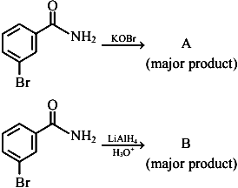

In the above reactions, product \(A\) and product \(B\) respectively are:

1. 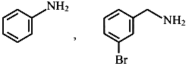
2. 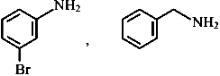
3. 
4. 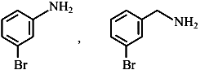

## Question 88



Consider the given reaction, percentage yield of,

1. \((C)>(A)>(B)\)
2. \((B)>(C)>(A)\)
3. \((A)>(C)>(B)\)
4. \((C)>(B)>(A)\)

## Question 89

The products A and B formed in the following reaction scheme are respectively



1. 
2. 
3. 
4. 

## Question 90

What is the correct name for a molecule that has two amino groups in opposing (para) locations around a benzene ring?

1. Benzenediamine
2. Benzene-1,4-diamine
3. p-Aminoaniline
4. 4-Aminobenzenamine